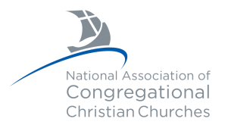 Pilgrim’s Progress
March 2026

“The purpose of this church shall be to bind together followers of Jesus Christ, for the object of sharing in the worship of God and in making His will dominant in the lives of men and women, especially as that will is set forth in the life and teachings of Jesus Christ.”
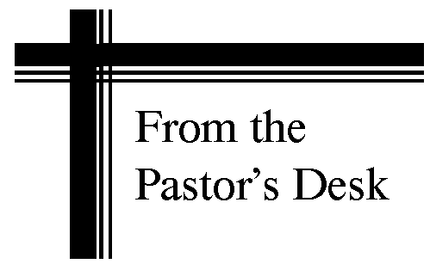
Palm Sunday is March 29, the last Sunday before Holy Week and Easter. It is noted for the contrast of peoples’ response to Jesus. On the day remembered we have Jesus entering Jerusalem with the people hailing Him as Messiah and celebrating His arrival. Within a few days, people were yelling for Him to be crucified and for a murderous rebel to be released. It notes the prophesied return to Jerusalem to rule in triumph and also emphasizes the fickle state of human nature. Palm Sunday gives us the hope of the returning Messiah, confidence in His trustworthiness and an understanding that people, even good people, even people who are sincere Christians are still capable of doing wrong, and that includes each of us. Beware of rash decisions and of temptations and circumstances that lead us to make such decisions. We can lead ourselves astray. That is one of the lessons of Palm Sunday.

Sermons for February
March 1 “He Chose to Forgive Us” Colossians 2:11-15; Isaiah 53:3-6
(sermon emphasis will be on Colossians 2:13-14)

March 8 “He Chose to Invite Us to His Presence” 1 Timothy 1:1-5; Exodus 33:17-20
(sermon emphasis will be on 1 Timothy 2:5)

March 15 “He Chose to Love Us Forever” John 3:13-21; Hebrews 10:19-22
(sermon emphasis will be on John 3:16-18)

March 22 John 12:20-26; Romans 8:35-39
(sermon emphasis on John 12:24)

March 29 Matthew 21:1-11; Psalm 118:1-2
(sermon emphasis on Matthew 21:15-16)

tttttttttttttttttttttttttttt

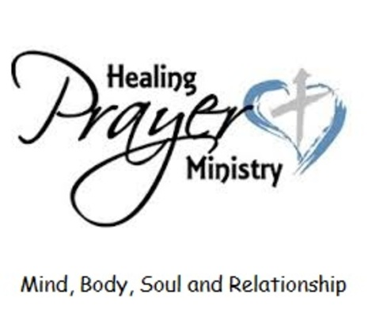
Please keep our Members in Care Facilities in your thoughts & prayers:
Bickford: Joanie Smith-Legg #108
Mill Pond Care Center: Romaine Mackaman
Glenwood Place: Elenor Tjossem #160, Lenora Brown #161
Westbrook Acres: Norma Dannen #12

tttttttttttttttttttttttttttt

Jeremy & Julie Lavender March 4, 2010 16 years
Bing & Dorothy McHone March 28, 1998 28 years

ttttttttttttttttttttttttttt


March 2 Kayla Bogenrief March 14 Dorothy McHone
March 4 Barbara Ellcey, Erin Stanley March 15 Julie Paustian
March 7 Barb Hibbs, Erin Jensen March 21 David Dysart
March 8 Caroline Lavender March 22 Raymond Kersbergen
March 9 Bob Bauer March 24 Lenora Brown
March 10 Greg Meyer, Reed Swartz March 29 James Allison

tttttttttttttttttttttttttttt

Meals On Wheels

The mission’s team is still committed to doing our part for Meals on Wheels in Marshalltown! Our part is, one Saturday a month (the fourth Saturday) and we do the east route. Please sign up in the narthex or call the church office (641-752-4239) to volunteer. You will be making a difference for someone that day and it feels good to help. Any questions please call me Kristi Hassler 641-750-3946 or Doris McCarty 641-752-7604.

Available Dates for 2026
April 25 July 25 September 26 October 24 November 28
- Did you know that Meals on Wheels is a non-profit, is self-funded, it does not receive state or federal assistance, the meals are paid by the client, and insurance does not cover meal charges? The organization provides healthy meals 365 days a year. Clients can choose daily delivery or customize for certain days a week.
- Did you know drivers are the heart of the program and you can volunteer as an individual or a group? First Congregational Church provides a driver the 4th Saturday of every month. Check the clipboard in the Narthex for opportunities to deliver. There are still some months to cover in 2026!
- Did you know monetary tax-deductible donations are always accepted and appreciated? Donations may be used to offset meal charges for some clients in need. Donations can be mailed to Carrie Loney, Meals on Wheels of Marshalltown, 2615 Smith Ave, Marshalltown, IA, 50158.
- Did you know they have a website www.mealsonwheelsofmarshalltown.com?

Thank you to all of our volunteers and for any consideration you can give to this organization.
-Doris McCarty & Kristi Hassler, BMC

ttttttttttttttttttttttttttt

A shopping cart is available in the back in the Narthex for any mini food pantry items. Please consider this when you are doing your shopping. Items will be delivered to the different food pantries around town when there is something to be picked up. Thank you Again, -Kristi Hassler, BMC

ttttttttttttttttttttttttttt

Youth Group News

Power Hour/Sunday School - Sundays, 9:15 -10:20 AM in the Loft for Preschool-12th grade
March 1, 8, 15, 29th (Not 22nd, Spring Break)

DOG’s (Depend on God) - Tuesdays, 5-6 PM in the Fellowship Hall for preschool-4th grade
March 3, 10, 24, 31 (Not 17th, Spring Break)

Jr. PY (Pilgrim Youth) - Wednesdays, 4:45-6 PM in the Loft for 5-8th grade
March 4, 11, 25 (Not 18th, Spring Break)

PY (Pilgrim Youth) - Wednesdays, 4:45-6 PM in the Loft for 9-12th grade
March 4, 11, 25 (Not 18th, Spring Break)
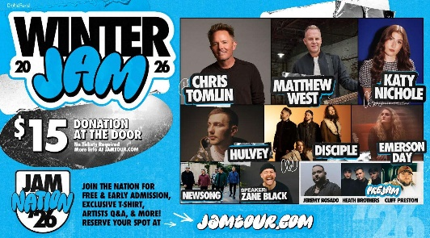

Sunday, March 15th we are taking a group to the WinterJam Christian Concert in Des Moines, IA. All students 5-12th grade are invited to join us. Please contact Shelly Speas for more info.

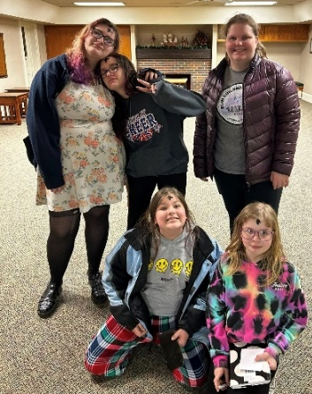
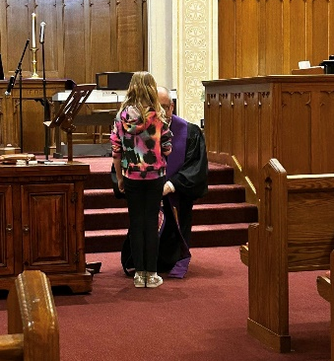

On Wednesday, February 18th the youth group attended the Ash Wednesday service and I got a quick picture of some of the kids after the service. It was a special service and great start to the season of lent.

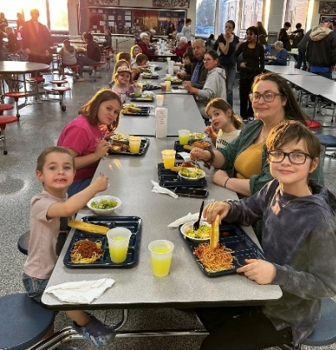
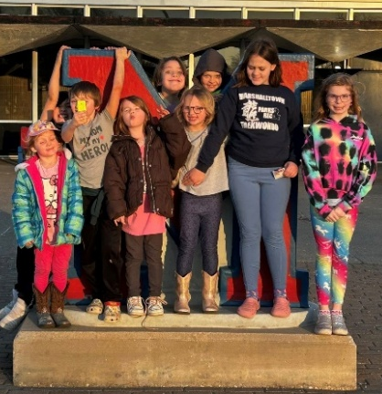

We took the DOG’s group to the pasta dinner MHS band fundraiser and had so much fun.

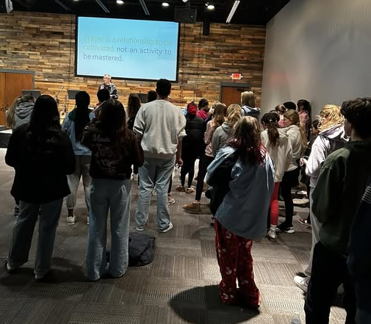

Our 5-12th grade youth were happy to join other youth groups at Grace Church at the end of January for a combined prayer night.

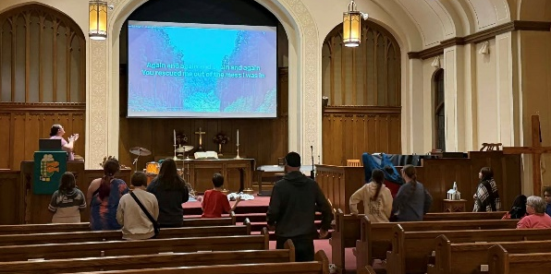
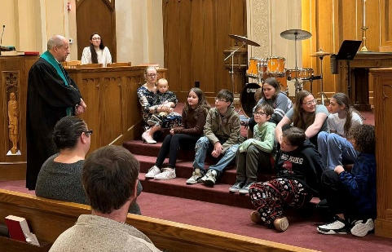
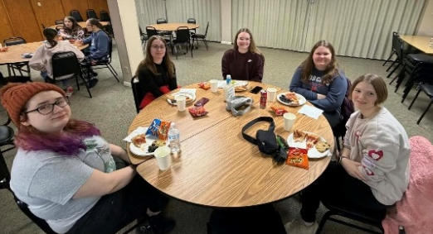
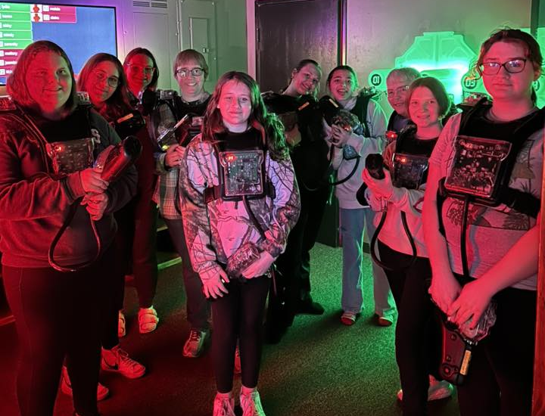

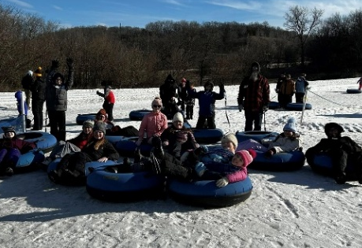
We had a Winter Retreat in February with our youth group. We were happy to have the youth leader and one of her youth from the Congregational Church in Elkador join us for the weekend. We had a great time together tubing in Boone, playing laser tag in Ames, and
coming back to have an evening devtional, play games, and watch a movie at our church.

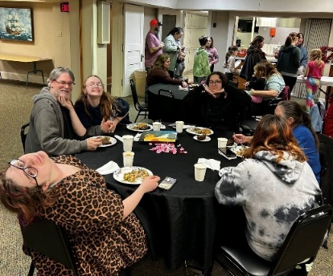
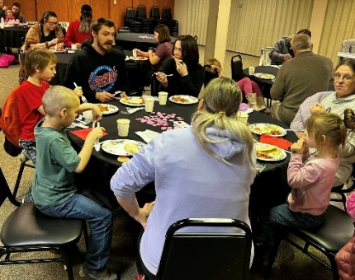
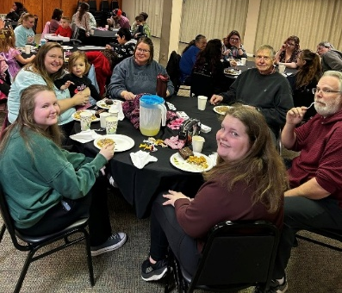
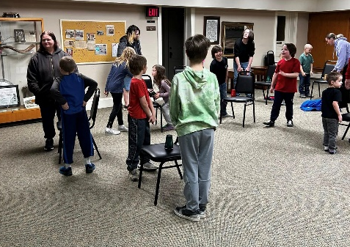

We had fun with our youth groups and their families in February as we hosted love on your family nights. We had dinner and played games together with a message at the end of the night.

ttttttttttttttttttttttttttt
Diaconate News

The end of December sped by as has January. It seems like yesterday it was the Christmas season and now we are in the season of Lent.

February 18th was the beginning of Lent and the Ash Wednesday Service was held at 7:00 that evening. It was a service of prayer, reflection, music and the imposition of ashes on the foreheads or hands of those who wanted to participate.

March 29th will be Palm Sunday and Easter is on April 5th this year. The Diaconate is planning to have the Memorial Easter Flower garden this year. Be watching for information in your Sunday bulletins soon.

Judy Gaynor & the Members of the Diaconate

ttttttttttttttttttttttttttt
Pillars of Faith @ F. C. C.

For those of you who read “Pillars of Faith” in February, the person was Gary McKibbin. If you haven’t read this article in the church’s newsletter and you have a computer, you can find it at this web site: https://www.fccmarshalltown.org/newsletter Thanks, Gary, for all you have done, do, and will do!

One of the definitions of a pillar is: a person or thing regarded as reliably providing essential support for something. The Biblical definition of faith is found in Hebrews 11:1 which says, “Now faith is the assurance of things hoped for, the conviction of things not seen.” Revised Standard Version. Also in the New King James Version of the Bible, Paul writes in Ephesians 2:8-9, “For by grace you have been saved through faith, and that not of yourselves; it is the gift of God, not of works, lest anyone should boast.” This gift of God is the reason the receivers of this gift want to be the hands and feet of Jesus on earth. So, with these two things in mind, we would like to present the “Pillar of Faith” for March.

Before I introduce this month’s Pillar of faith, this author finds it interesting that the last few Pillars of Faith have originally come from different parts of Iowa and the surrounding area. Maybe it was a job that brought them to Marshalltown but what brought them to First Congregational Church? I believe it is a sense of belonging first to the Triune God, (God the Father, God the Son and God the Holy Spirit) which causes one to seek to belong to a like minded community. Our Pillar of Faith for March 2026 is no exception.

I was born in Marshalltown in the late ‘40s the granddaughter of an E. U. B. minister. I grew up in a small town 33 miles northeast of Des Moines and went to a Congregational Church there. I attended Sunday School, Vacation Bible School and Confirmation Classes. I also participated in Pilgrim Fellowship and sang in the choir. I married in my hometown church and we moved to Marshalltown 46 years ago. After we were settled we attended other churches, however when we came to FCC, it was friendly and welcoming. “It felt like coming home to church.” The service was what I was used to. We joined over 40 years ago.

My first involvement in church activities was on the Board of Christian Education. Then the on Hospitality Committee where two other people and I planned dinners, funerals and maybe fellowship time after the 10:30 church service. I was on the Nominating Committee and now a member of the of the Stamp Club.

In the ‘80s I was a chaperone to the NAPf convention in Sacramento, California. We spent two weeks sleeping and camping in churches. Our oldest daughter went too which made it extra special. It was fun but a lot of work. Also in the ‘80s I was on the Pastoral Search Committee it was very informative and interesting. We hired Pastor Greg Ellcey to be our Pastor. As our children grew I taught Sunday School and after our children grew up we went to the 8:00 service in the FCC Chapel. The Chapel was a small intimate group. My Mom attended with us as well. “What I liked about it was I felt like the pastor was talking to me. It was a personal service.”

When asked, “Which activity did you enjoy the most?” The answers was, “Being a member of the Stamp Club. I make cards for members of our church and others. It is my happy place!”

When asked, “Do you have any advice for the future of our church?” This was the answer, “Do unto other as you would have others do unto you. It prompts friendship, communication and respect. i think that is the way our church should be.”

Now if you are wondering why this person’s name was not mentioned, it wasn’t a mistake. Can you guess who this person is? If not, be sure and read your April 2026 newsletter. The answer will be there under the title “Pillars of Faith @ F. C. C.”

ttttttttttttttttttttttttttt

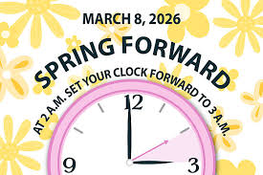



FCC CALENDAR OF EVENTS!
Sunday Worship Services:
8am & 10:30am in person
10:30am Service is also on You Tube
SUNDAY | MONDAY | TUESDAY | WEDNESDAY | THURSDAY | FRIDAY | SATURDAY

Monday-Friday
9 am-Noon
641-752-4239
color code:
youth events
Church mtgs
Special events
Comm. Events
Color copy on bulletin boards
1 Communion  In-Person Worship  8am and 10:30 svcs  In Sanctuary  10:30 Svc/YouTube  Fellowship follows  Power Hour 9:15  Cabinet Meets 11:45 AM | 2  Women’s Ministry @ 5:30 PM | 3  DOGS: 5-6 PM | 4  Men’s church coffee 8 AM Hy-Vee  Jr PY: 4:45-6 PM  PY: 7-8:15 PM | 5  Bell choir 5:30 PM | 6 | 7
8 Daylight Savings  In-Person Worship  8am and 10:30 svcs  In Sanctuary  10:30 Svc/YouTube  Fellowship follows  Power Hour 9:15 | 9  Women’s Bible Study @ 5:30 PM  Trustees meet @ 6 PM | 10  DOGS: 5-6 PM  BMC meets @ 8:45 AM | 11  Men’s church coffee 8 AM Hy-Vee  Jr PY: 4:45-6 PM  PY: 7-8:15 PM | 12  Bell choir 5:30 PM | 13 | 14
15  In-Person Worship  8am and 10:30 svcs  In Sanctuary  10:30 Svc/YouTube  Fellowship follows  BCE meets 11:45 AM  Power Hour 9:15 | 16 | 17  Diaconate meets @ 6:30 PM | 18  Men’s church coffee 8 AM Hy-Vee | 19  Bell choir 5:30 PM | 20 | 21  11 AM MOW  John & Lisa Blabaum
22  In-Person Worship  8am and 10:30 svcs  In Sanctuary  10:30 Svc/YouTube  Fellowship follows | 23  Women’s Bible Study @ 5:30 PM | 24  DOGS: 5-6 PM | 25  Men’s church coffee 8 AM Hy-Vee  Jr PY: 4:45-6 PM  PY: 7-8:15 PM | 26  Bell choir 5:30 PM | 27 | 28
29  Palm Sunday  In-Person Worship  8am and 10:30 svcs  In Sanctuary  10:30 Svc/YouTube  Fellowship follows  Power Hour 9:15 | 30 | 31  DOGS: 5-6 PM



First Congregational Church
312 W. Main St.
Marshalltown, IA 50158

Office hours 9 a.m. - noon Mon – Fri. 641-752-4239
Worship Services: 8 a.m. & 10:30 a.m.
Sunday School: 9:15 a.m. All ages in the LOFT
web page: www.fccmarshalltown.org

A member of the National Association of Congregational Christian Churches

